# Kickstarter Analysis Report

1. Given the provided data, what are three conclusions we can draw about Kickstarter campaigns?
2. Even though “theater” category has the highest number of startups almost 34 % of total percentage of all categories. Music takes a lead on the Success Rate. Almost 77% of the total Kickstarter started were successful.

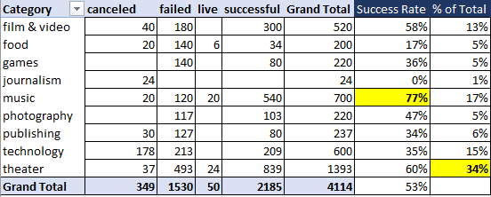

“Plays” seems to be the most popular subcategory in the theater category with the highest number of startups started. It has 65 % Success Rate and 33% of Failure rate.

The second biggest subcategory is rock with 100% Success rate

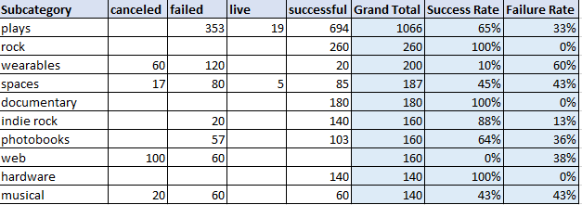

1. **Peak year and Month for startups**

**Assumption - 2017 data can be excluded for analysis it has partial months data.**

A lot of new kickstart picked up in the later years after 2012 with the greatest number of new Kickstarter started in 2015 based on the sample dataset provided.

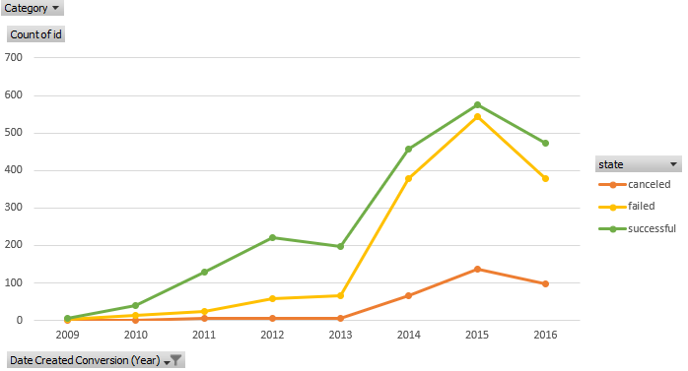

Mid of the year has the largest number of launch during the month of May-July

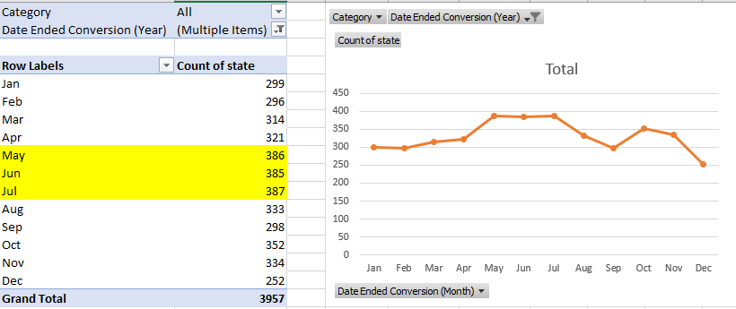

1. Based on the sample dataset and it may not be true with bigger data set, the bigger the goal amount the percentage of failures has increased.

The startups with lower goal succeeded better than the companies with the higher goal.

Mid-range goal valued companies had almost equal probability of failure and success.

The data shows 258 failure out of 444 with a goal greater than or equal to 500000.

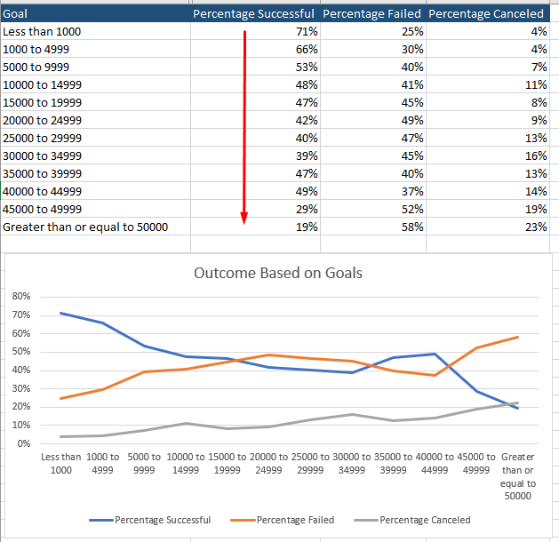

1. **What are some limitations of this dataset?**

The dataset is comparatively small considering the number of categories and subcategories, to draw significant insights. There is relatively large number of startups for the Theater category and thereby it is easier to conclude that Theater is the most popular category but it may not be the case as it is just the sample dataset.

It will be good to have additional information on each of the Kickstarter’s goal and mission.

There are a lot of outliers in the dataset can thereby result inaccurate conclusion.

Year 2017 has partial data that can result in incorrect conclusions with partial results for the year when it comes to drawing conclusion on which month has the greatest startups or launch.

1. **What are some other possible tables and/or graphs that we could create?**

There are a lot of other charts we can create with the sample dataset provided

1. Top 10 successful category/subcategory along with the least popular one’s.
2. Analyze the data country.
3. Categorizing big companies with larger goals to smaller with lesser goals and then comparing the outcome for each category/subcategory
4. Display average donation for each category. Also check for some outliers like Technology received the maximum average donation by one.
5. It will be interesting to see the duration between when the kickstarted was started and when it was launched for each company, category, and subcategory. And analyze the data around those parameters.
6. Analyze the Percentage funded for each category to the success rate.
7. Which category and subcategory were backed the most?
8. Display the success rate for each category and subcategory